# **Validation Report Cost-Obj**

## *Summary Report*

*OBJECT*

IfcSlab.FLOOR

GlobalId: 3qgEayMZ55yxnk8LFa1i7K

Obj Name: Pavimento:PAV_STR_LT_30_CA5_LT25:139442

*COST ITEM*

IfcCostItem

Price List Code: LP.EEA.a04.A1020.Qa000.0035.-

GlobalId: 0_J5mxpN98khPvl_X5nE1p

Cost Name: Wood formwork for slab

*CHART*

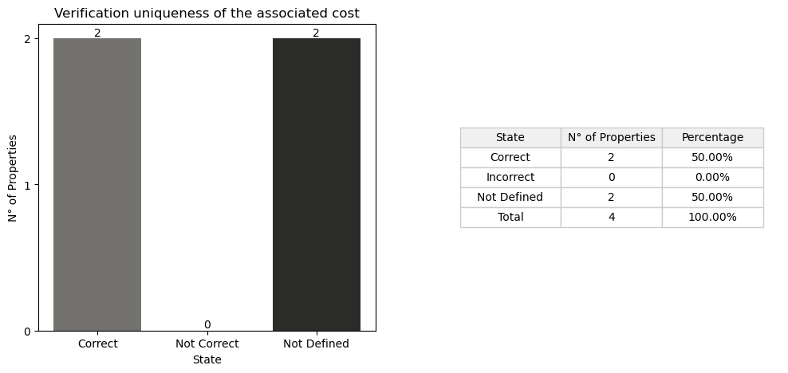

## *Detail Table*

|  |  |  |
| --- | --- | --- |
| **State** | **N° of Properties** | **Properties** |
| Correct | 2 | Entity TypeEnum |
| Incorrect | 0 |  |
| Not Defined in the obj | 2 | Status ConstructionMethod |
| Not Defined in the cost | 0 |  |
| Not Defined in the cost and obj | 0 |  |

## *Detail Report*

**🔸Number of Correct Properties: 2**

Entity: ✓   
 • IfcSlab  
  
TypeEnum: ✓   
 • #1100=IfcSlab('3qgEayMZ55yxnk8LFa1i7K',#21,'Pavimento:PAV_STR_LT_30_CA5_LT25:139442',$,'Pavimento:PAV_STR_LT_30_CA5_LT25',#1092,#1099,'139442',.FLOOR.)

**🔸Number of Incorrect Properties: 0**

**🔸Number of Not Defined Properties in Obj: 2**

Status: ✗   
 • property not found in OBJ  
  
ConstructionMethod: ✗   
 • property not found in OBJ

**🔸Number of Not Defined Properties in Cost Item: 0**

**🔸Number of Not Defined Properties in Cost Item and Obj: 0**